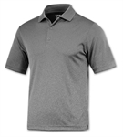 XT48 Men’s Xtreme-Tek Polo $28.00
XT 47 Women’s Xtreme-Tek Polo $28.00 S, M, L, XL ______
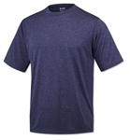 XT76 Men’s Xtreme-Tek T-shirt $15.00
XT77 Women’s Xtreme-Tek T-shirt $15.00 S, M, L, XL ______
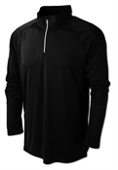 XT424 Men’s Xtreme-Tek Qu-zip Pullover $26.00
XT425 Women’s Xtreme-Tek Qu-zip Pullover $26.00 S, M, L, XL ______

Each item will have the CKSOA logo on the front of the item. Total _____
Email your ORDER TO JUSTIN WOODSIDE, cksoa.president@gmail.com by JUNE 30, 2016
Checks payable to CKSOA, to Justin Woodside 310 Dogwood Court Versailles, KY 40383

